SHREERAM MODEL SCHOOL
ENGLISH GRAMMAR – WORKSHEET CLASS 2
TOPIC IS, AM, ARE, WAS, WERE AND PICTURE COMPOSITION

EXERCISE 1
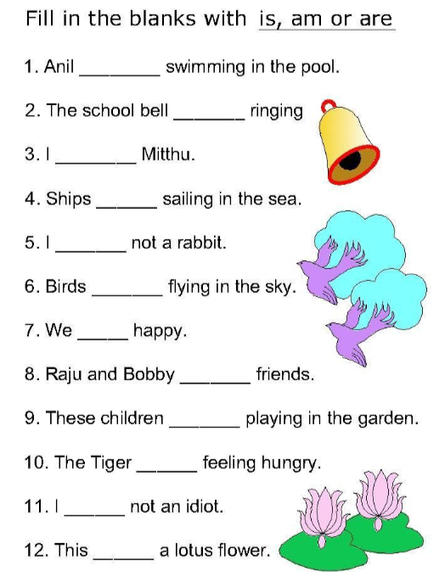

EXERCISE 2
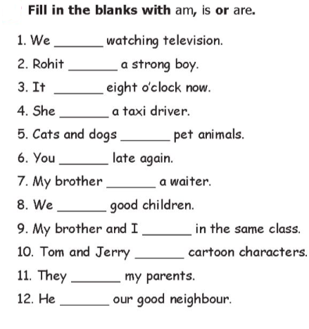

Exercise 3
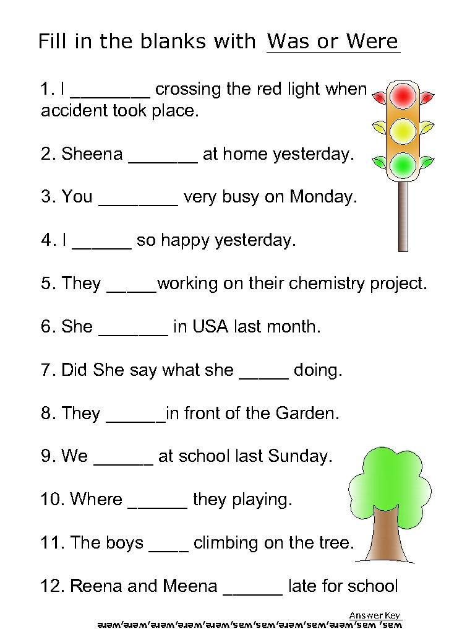

Exercise 4

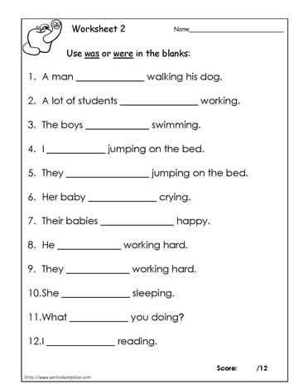

Examples of Picture Composition
- This is a picture of classroom.
- There are seven students in the classroom.
- They are enjoying their art and craft class.
- A student is showing art book to the teacher.
- The teacher is wearing specs.
- Two students are talking in the class.
- There is a beautiful board on the wall.

- This is a picture of garden.
- There are some children and a woman in the garden.
- The garden is full of big trees and green grass.
- The woman and a girl are sitting on a bench.
- Two kids are climbing the tree.
- A boy is running with his dog.
- A girl is riding on her scooter.

- This is a picture of room.
- There are four people in the room.
- Father and mother are sitting on the sofa.
- Mother is reading newspaper.
- A table lamp is kept on the table.
- The table has two drawers.
- Children are playing with toys.

